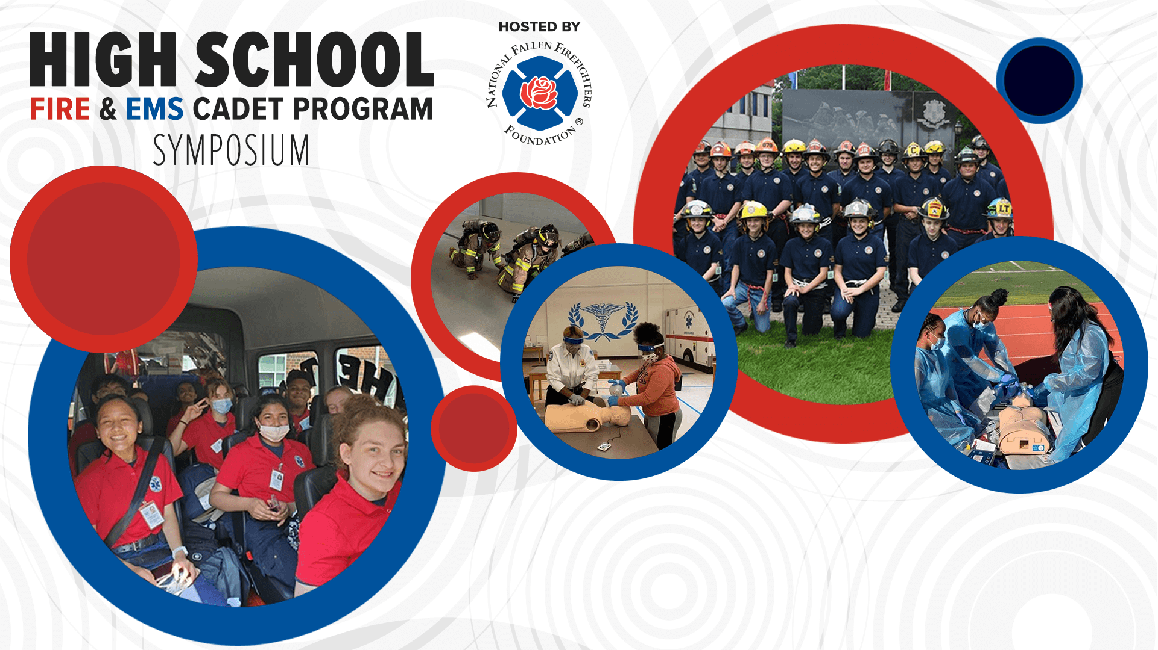

|  |  |  |  |  |  |  |  |  |  |
| --- | --- | --- | --- | --- | --- | --- | --- | --- | --- |
| |  |  |  |  |  |  |  |  |  | | --- | --- | --- | --- | --- | --- | --- | --- | --- | | |  |  |  |  |  |  |  |  | | --- | --- | --- | --- | --- | --- | --- | --- | | |  |  |  |  |  |  |  | | --- | --- | --- | --- | --- | --- | --- | | |  | | --- | | Join us at this year's National Fallen Firefighter's Foundation [**2023 High School Fire & EMS Cadet Program Symposium**](https://cvent.me/93oPY5) on July 22, 2023. Learn from and be among colleagues specifically interested in sharing general information and effective practices with their peers from across the nation. | | This is the 4th event in a series dating back to 2019. Stakeholders from 22 states and the District of Columbia have joined us in the past, spending two days learning from and networking with learning professionals, subject matter experts, and leaders of successful programs. Outcomes were impressive: | | * 100% of attendees agreed that the symposium provided them with tools, resources, and best practices that could be put to use in their current program. * 100% said the event provided a networking opportunity that enabled them to meet and interact with their peers. * 100% planned to continue engagement with fellow attendees (via the group's social page, direct communication, or other means) to share ideas and best practices. | | The NFFF is now taking this event to Detroit, Michigan. There is **no registration fee to attend**! | | Attendees will experience a highly interactive agenda. Topics will address: | | * Techniques to reach the new Generation of Learners * Funding the Program (Perkins Grants) * Building the Program from the Start * Mentorship Program with Pflugerville Fire Department * Program Structure and Scheduling * Preparation for State Exams * Managing your Budget * NFFF Training Resources | | | | |
| |  |  |  |  |  |  |  | | --- | --- | --- | --- | --- | --- | --- | | |  |  |  |  |  |  | | --- | --- | --- | --- | --- | --- | | |  |  |  |  |  | | --- | --- | --- | --- | --- | | |  | | --- | | **Please join us and secure your spot by** [**registering today**](https://cvent.me/db7vG0)**!** | |  | | *Funding for this program has been provided through* | | *FEMA’s Grant Program Directorate for Assistance to Firefighters Grant Program – Fire Prevention and Safety Grants* | | | | |

